**LAB 2 - INTRODUCTION TO ASSEMBLY**

**AIM**

Writing a program in Assembly using the MARIE Simulator to find the sum of the following equation and store and display the output.

**Introduction**

MarieSim is a rich graphical machine simulation environment. Its features are best appreciated after you have experimented with a simple program or two. This guide presents the basic steps required to enter, assemble, and execute a program.

Screen shots

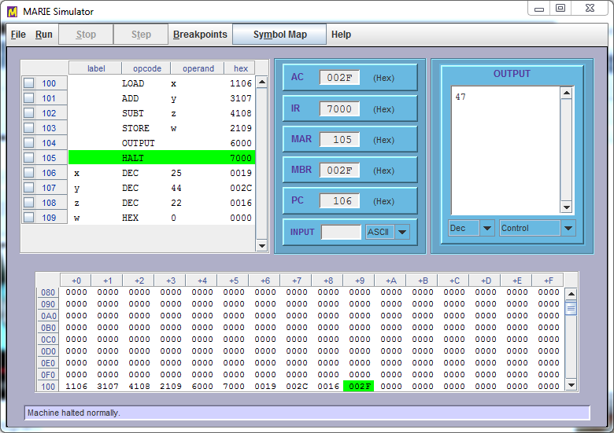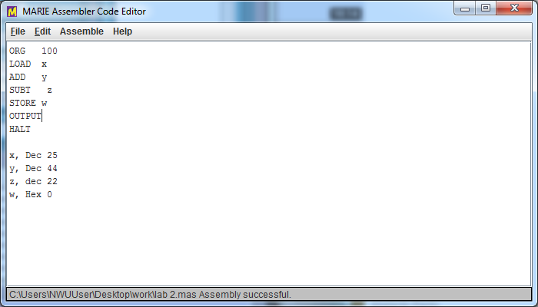

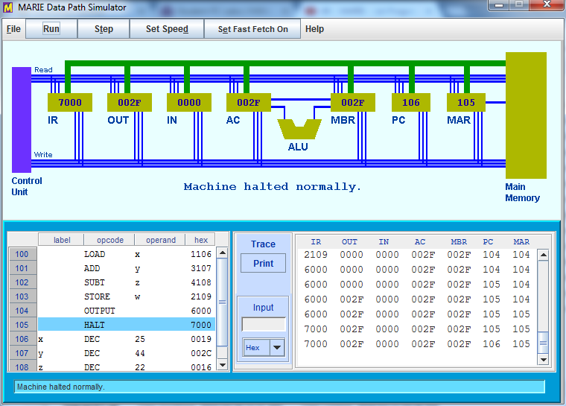

**Procedure**

Installed the marie simulator ,then opened a notepad text editor ,then typed the required code ,saved it in a .mex file format ,then loaded the .mex file to the marie simulators to show the simulation of how the CPU function.

**Discussion**

Firstly we stated by writing our program of adding x and y the subtract z the results well be given by a variable w. Then we assembled the current file after we loaded, we ran the program which gave us the results of 47 using decimal option. We opened the dip1.jar ran the program again and it **smoothly ran and the CPU successfully operated.**

**Conclusion**

The simulation was successfully done. The expected simulation results corresponded with the AIM of the lab 2 task.

#7672542bB